Putting items on reserve using LibGuides

Scanned items …
Put scanned items in the W drive as usual. SUGGESTION…WHEN SAVING YOUR RESERVE DO NOT USE SPACES!

Making a new Course Reserves LibGuide
At the beginning of every semester / summer term you have to make a new reserves LibGuide. The good news is that you don’t have to make it from scratch … you can copy an old one.
- Log-in to your libguides account. To do this, go to the Reserves page. And click on the “Admin Sign in” link near the top of the page. Your login is your email. If you forget your password, you can get reset yourself by clicking on the forgot your password link.
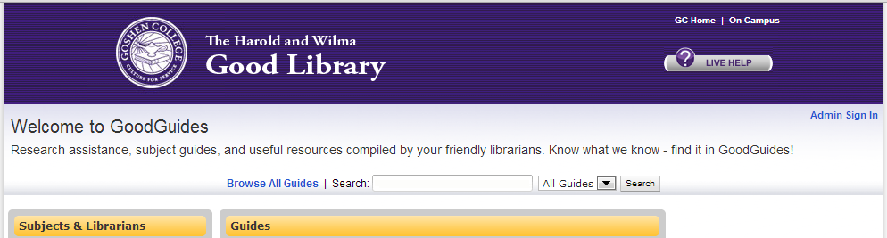

- At the top of the page, click Dashboard at the top of the page. 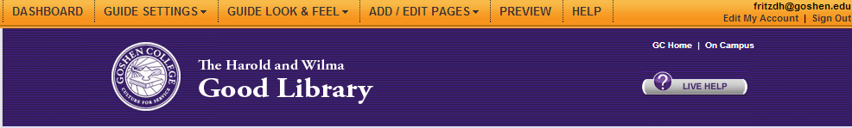
- On your Dashboard page, look for the “Create New guide” link in the middle of the page. 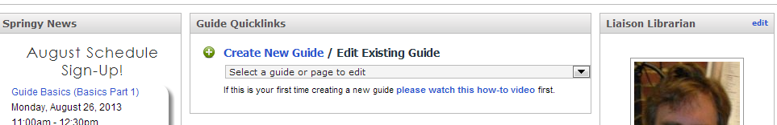
- On the Create New Guide page, change the radio button from “Start Fresh” to “Use a Template”.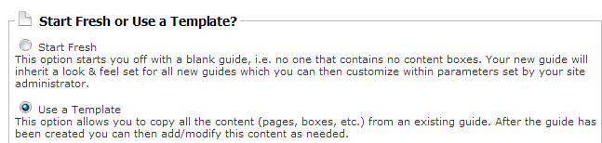
Once you click on Use a Template, a search bar will appear allowing you to search for the guide you want to copy. You can also see a list of our guides by clicking on the “switch to the dropdown list of guides” link. 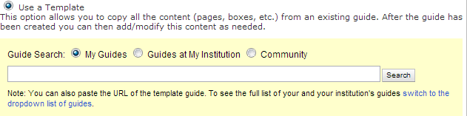
Navigate to a previously made Reserve guide (any will do) and click on it.
- Once you have selected a guide to use as a template, give the new guide a title by typing it in in the Guide Settings box. Name the new guide the term, the current year, and Reserves (example Summer 2012 Reserves)
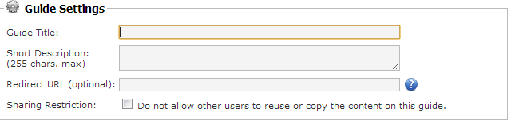
- Click on the “Create New Guide” button at the bottom of the page. You are now ready to edit your new guide.
- Once you are done with your Guide, let the person overseeing the website know so that he /she can update the reserve link on the website.

Editing Reserves …
- The reserves page looks something like this …
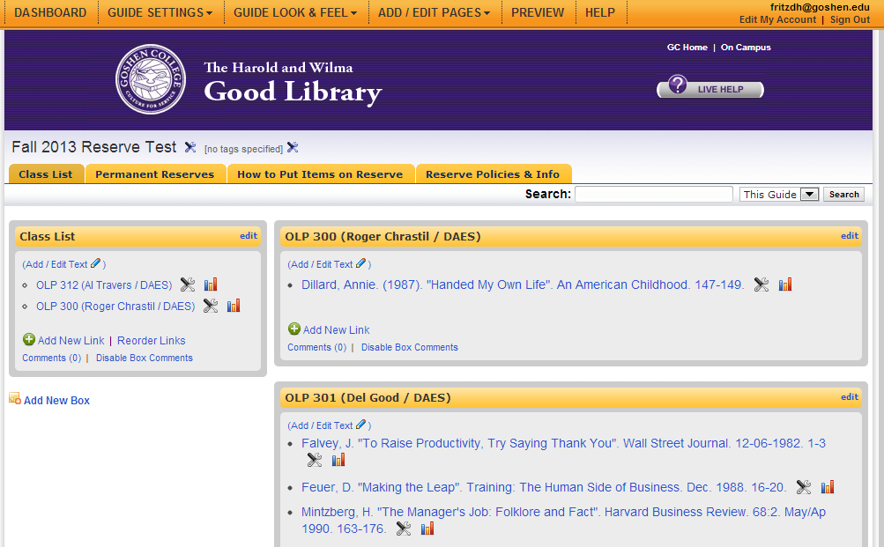
Guide Settings – you will have to click on this link to make the guide editable by other staff members and to make the reserves page public.
There are four tabs (pages) on the reserve guide. We are only interested in the “Class List”.
Each class gets a box with the class reserves listed in it. (see below for instructions on how to set up a list of reserves for a class)
The Class list box allows you to quickly browse the list of classes. (see below on how to set-up a link)

Setting up a class
- At the bottom of the right column, click on the “Add New Box” link.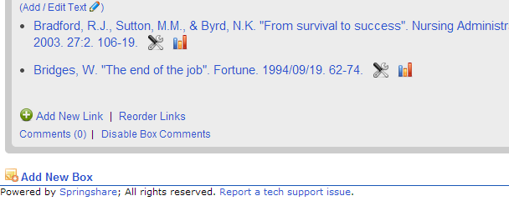
- An “add new box” popup will appear.
- In the “Select the Content Box Type” drop down menu, select “Links Boxes” and then “Links & Lists”
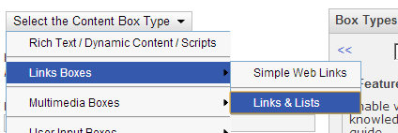
- In the Box Title field, put in the class symbol, class number, professors name followed by the slash, and the title of the Class. Example … OLP 312 Al Travers/Painting.
- In the position field, make sure you put the class in the right place alphabetically.
- Click on the “Create Box” button at the bottom.
- Adding the class to the “Class List” box
- Locate the box you just created, and click on the “edit” button on the top title bar. 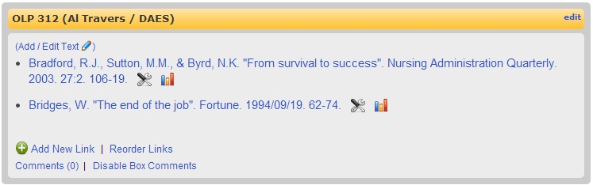
- Select “Edit Box Info” 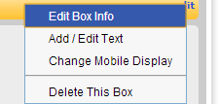
- Select the “Box Link & Embed Code” tab. Highlight and copy (ctrl+c) the url in the top line.
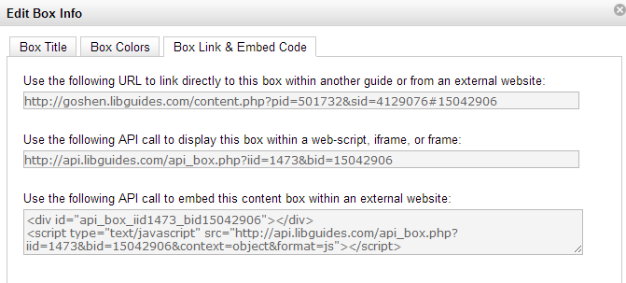
Click on the “X” to close out the pop-up window.
- The “Class List” box is the only box in the left column. Click on the “Add New Link” button
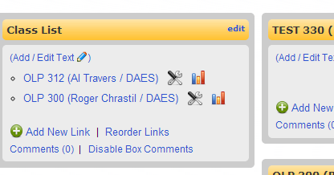
- The “Add New Link” pop-up box appears.
  - Link Title: Use the same title you used for the class box
  - Link URL: Hit ctrl+v to paste in the url you just copied
  - Window Target: select “Open link in same window”
  - Click on “Create new link”
  - Note you may have to put the link you just made into the proper order. Which you can do by clicking on “Reorder Links”
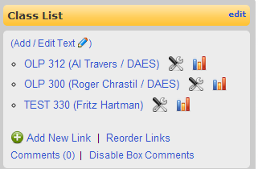

Adding Reserves to your class
- In the class box, click on “Add new Link”
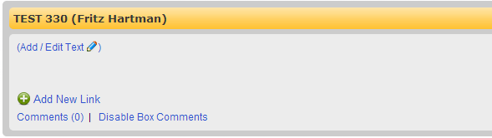
- Fill out the Edit/Delete Link popup accordingly
  - Link Title: Fill out the bibliographic data in whatever citation style you want to (MLA, APA etc…)
  - Link URL: Put in the url to the resource.
- If the resource is in a database, you use the constant link.
- If the link is on the W drive, the link should go… http://www.goshen.edu/library/Reserve/NAME_OF_ FILE/NAME_OF_RESERVE.pdf
- If the resource is on the print reserve Shelf leave the link url field blank and add the following phrase in the DESCRIPTION field …
“SHELF RESERVE. ITEM LOCATED IN THE LIBRARY AT THE CIRCULATION DESK” 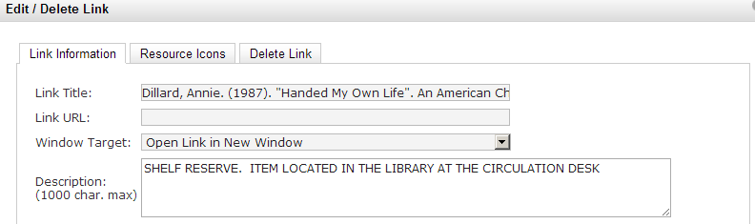
- Remember to click on the “Save Changes” button at the bottom of the page
- Once you have all of your reserves added, click on “Reorder links” to put the reserves in alphabetical order.
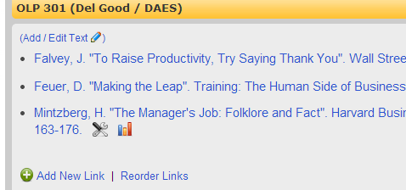

Deleting Stuff
- To delete specific links from “Class List” and the Reserve Boxes click on the wrench and screwdriver icon next to the link.
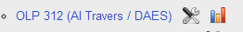
- To delete an entire class, click on “edit” on the title bar of the box and select “delete this box”
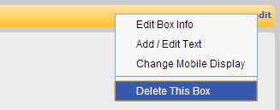

Making the Guide “public” or making it “private”
- To change the status of your guide, click on “Guide Settings” at the very top of the page and select “Change Guide Information”
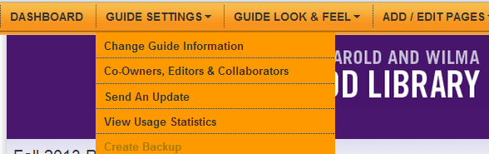
- Look for the “Guide Publication Status” field
You have to make your guide “public” when you first create it in order for anyone to see it!
- Click on “Save” at the bottom.

Giving the Guide a Friendly Url (optional)
- To give the guide a friendly url, click on “Guide Settings” at the very top of the page and select “Change Guide Information”
- Look for the “Friendly URL” field. Give the guide a url that is easy to remember. SUGGESTION: DO NOT USE SPACES
- Click on “Save” at the bottom.

Assigning Editors
- To make it so that others can edit the guide, click on “Guide Settings” at the very top of the page and select “Co-Owners, Editors & Collaborators”
- In the Editors sections, pick the editors you want and click “add” to the side. SUGGESTION: Make the librarians and those who are most likely to use the guide editors.
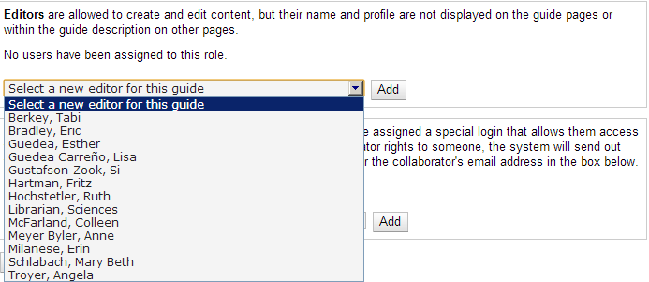
- Click on “Save” at the bottom.

